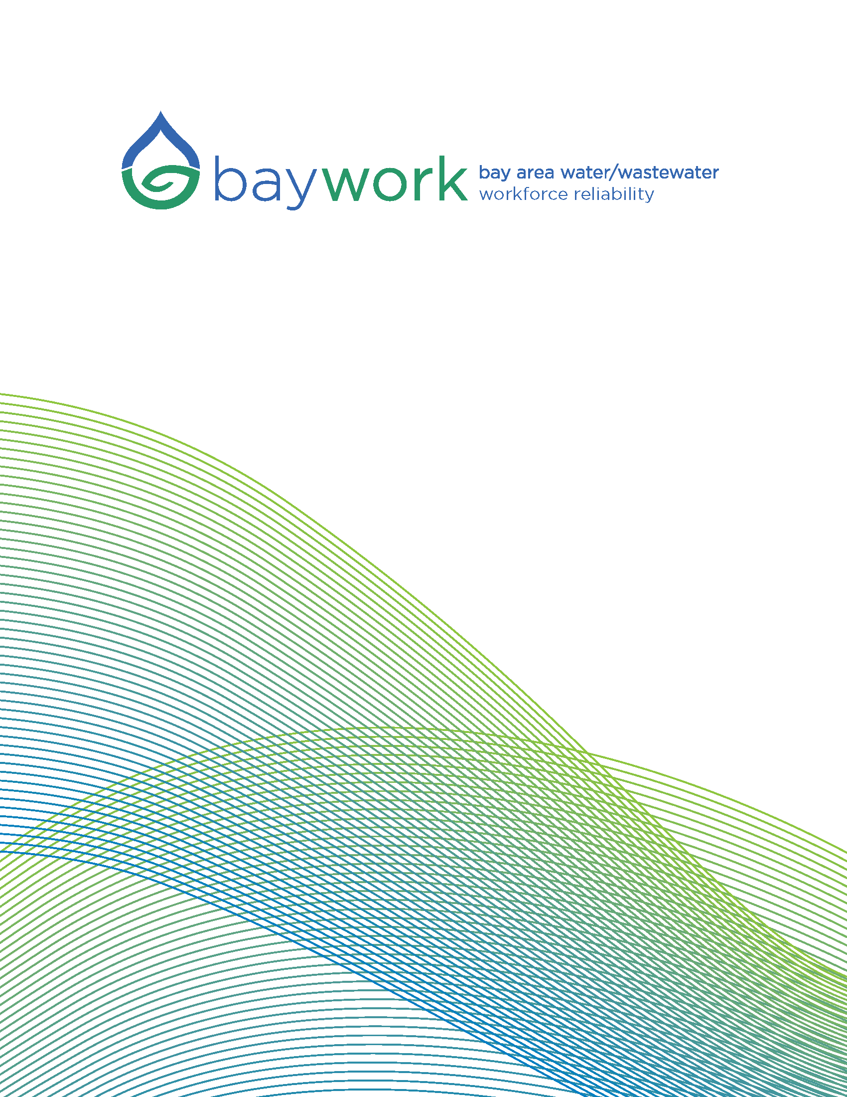

GO WITH THE FLOW

TEACHER’S GUIDE

East Bay Municipal Utility District

2/16/2018

COVER SHEET

GO WITH THE FLOW

Cover Sheet for Instructors/Students

Water and wastewater treatment plants process very large quantities of water, sometimes 20-35 million gallons per day or more, depending on the size of the cities they service. Water Treatment Operators have to know how long it will take for water to get from one place to another based on “flow rate”, which is measured in millions of gallons per day (MGD). The time it takes for water to flow from one end of a pipe or
tank to the other is called “detention time”.
Water Treatment Operators introduce chemicals into the water supply to remove particles in the water and to disinfect it so it is safe to drink. Have you had the experience of being in water that has been treated? Well, if you’ve ever been in a pool then you have been in water treated with chlorine.
Wastewater treatment facilities must treat enormous quantities of water with very specific quantities and combinations of chemicals at very precise moments in time as the water flows from the beginning to the end of the treatment plant. Therefore the plant operators who are responsible for treating the water must be able to calculate the volume of water and the speed at which it moves from one place to another. (“detention time”)
Here are some terms and mathematical concepts that must be understood before a student can make these flow rate calculations accurately:
Volume: In this context we will be talking about square or rectangular basins. (See additional problem below to deepen learning and consider a cylindrical pipe)
The volume of water in a rectangular basin is obtained by calculating the product of the length and width of the basin and then multiplying that figure by the height of the water. Notice, the height of the water is not the same as the height of the tank.
Conversion: 7.48 gallons of water = 1 cubic ft.
Therefore 1 gallon of water occupies 0.133689 cubic feet. (Do you see how we obtained this number?)
If we calculate the volume of a basin in cubic feet, we can easily convert that volume number to gallons. In other words we can find out how many gallons would occupy a certain sized container.
If you are given flow rate in terms of gallons per day, can you convert that number to gallons per hour? How? What about gallons per minute or gallons per second?
Now imagine a fixed quantity of water flowing through a basin…would the water flow more quickly or more slowly if the basin were smaller? Are you sure? How can you test this hypothesis?

WARM-UP EXERCISE

GO WITH THE FLOW
WARM-UP

- A water reservoir at EBMUD has a volume of

11,454 ⁵
8
cubic feet.

What are the possible dimensions of this reservoir?

  - 11 ft wide 45 ft long 4 ⁵
8
ft deep

  - 22.75 ft wide 38 ft long 14.25 ft deep

  - cannot be calculated

  - 13 ¼ ft wide 22 ¾ ft deep 38 ft long

- Convert 15 million gallons per day to gallons per minute.

VIDEO



http://baywork.org/resource/go-with-the-flow-contextualized-learning-video/

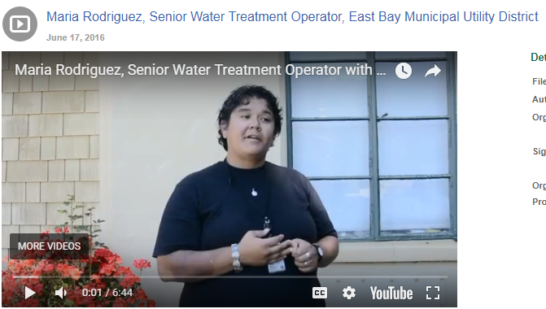

http://baywork.org/resource/maria-rodriguez-senior-water-treatment-operator-east-bay-municipal-utility-district/

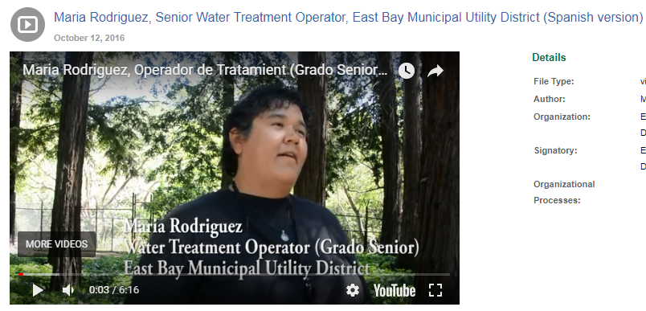

http://baywork.org/resource/maria-rodriguez-senior-water-treatment-operator-east-bay-municipal-utility-district-spanish-version/

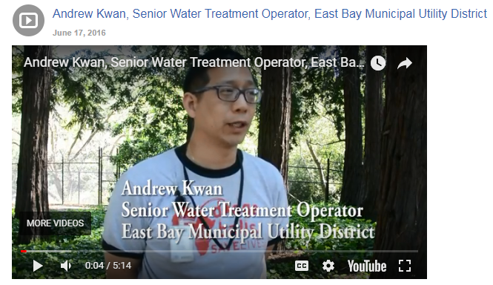

http://baywork.org/resource/andrew-kwan-senior-water-treatment-operator-east-bay-municipal-utility-district/

WORKSHEET

GO WITH THE FLOW
Worksheet for Students
Consider a water treatment plant that has two rectangular basins. The basins are next to each other, side by side. The raw water from a lake or river flows into the plant and is divided equally into the two basins. We will refer to these as Basin 1 and Basin 2. Basin 1 mixes the treatment chemicals to coagulate the particles in the water, and Basin 2 allows the coagulated dirt in the raw water to sink to the bottom of the basin. Basin 1 measures 62 feet-6 inches wide, 64 feet-6 inches long and 16 feet-6 inches tall. This basin contains 14 feet-9 inches of water. Basin 2 is 67 feet wide, 211 feet-6 inches long, and 18 feet-6 inches deep. This basin contains 16 feet-6 inches of water. The flow in each basin is 9.5 million gallons per day (MGD).
How long will it take for the water to flow from:
- The beginning of the Basin 1 to the end of the Basin 1?

- The beginning of the Basin 2 to the end of the Basin 2?

- The beginning of the Basin 1 to the end of Basin 2?

If the plant had a problem and needed to take a basin out of service to clean or repair it, as discussed in the video, this would have an impact on detention time. The entire plant flow of 19 MGD would have to flow through one basin instead of two.

- How would this change the detention time through that one remaining basin? [assume basin 1 has been taken out of service]

y

SOLUTION SHEET

GO WITH THE FLOW

Solution Sheet

Question 1: Calculate the volume and detention time of Basin 1 at a flow rate of 9.5 MGD:
Volume is length*width * height (water level) = (64.5 ft)*(62.5 ft)* (14.75 ft) =59,461 cu. ft.
How many gallons can 59,461 cu. ft hold?
(7.48 gallons/cu. ft) x (59,461 cu. ft) = 444,768 gallons in Basin 1.
Flow rate is 9.5 million gallons/day = 9,500,000 gallons/day *day/24 hours*hour/60 minutes = 6,597 gallons per minute (hint: how many minutes are in a day?)
So 444,768 gallons ÷ 6,597 gallons per minute = 67.4 minutes

This means that at a flow rate of 9.5 million gallons per day (which is equivalent to 6597 gallons per minute) all the water in Basin 1, which is 444,768 gallons, can get processed in 67.4 minutes
Question 2: Calculate the volume and detention time of the Basin 2 at a flow rate of 9.5 MGD:
Volume is length*width * height (water level) = (211.5 ft)*(67.0 ft)* (16.5 ft) =233,813 cu. ft.
How many gallons can 233,813 cu. ft hold?
(7.48 gallons/cu.ft) x (233,813 cu. ft) = 1,748,923 gallons in Basin 2
Flow rate is 9.5 million gallons/day = 9,500,000 gallons/day *day/24 hours*hour/60 minutes = 6,597 gallons per minute
So 1,748,923 gallons ÷ 6,597 gallons per minute = 265.1 minutes or 4.4 hours
Question 3: Calculate the detention time from the beginning of Basin 1 to the end of Basin 2 at 9.5 MGD:
The detention time of Basin 1 at 9.5 MGD is 67.4 minutes. The detention time of Basin 2 at 9.5 MGD is 265.1 minutes.
  - minutes + 67.4 minutes = 332.5 minutes or 5.5 hours
Question 4: Since the flow would increase from 9.5 MGD to 19 MGD the flow would double. Do you see why? The plant cannot decide to treat less water, they just have to reroute the water thorough the basins that are available.

Flow rate is 19.0 million gallons/day = 19,000,000 gallons/day *day/24 hours*hour/60 minutes = 13,194 gallons per minute
Basin 1 has been taken out of service. Basin 2 detention time is:
1,748,923 gallons ÷ 13,194 gallons per minute = 132.6 minutes or 2.2 hours
Consequently, the detention time through the basin would be half the time due to doubling the flow. (Compare answer to Question 2)

SUPPLEMENTAL
COVER SHEET

GO WITH THE FLOW: Supplement, cylindrical pipe

Cover Sheet for Instructors/Students

Water and wastewater treatment plants process very large quantities of water, sometimes 20-35 million gallons per day or more, depending on the size of the cities they service. Water Treatment Operators have to know how long it will take for water to get from one place to another based on “flow rate”, which is measured in millions of gallons per day (MGD). The time it takes for water to flow from one end of a pipe or tank to the other is called “detention time”.
Water Treatment Operators introduce chemicals into the water supply to remove particles in the water and to disinfect it so it is safe to drink. Have you had the experience of being in water that has been treated? Well, if you’ve ever been in a pool then you have been in water treated with chlorine.
Wastewater treatment facilities must treat enormous quantities of water with very specific quantities and combinations of chemicals at very precise moments in time as the water flows from the beginning to the end of the treatment plant. Therefore the plant operators who are responsible for treating the water must be able to calculate the volume of water and the speed at which it moves from one place to another. (“detention time”)
Here are some terms and mathematical concepts that must be understood before a student can make these flow rate calculations accurately:
Volume: In this context we will be talking about cylindrical pipes.
The volume of water in a cylinder is obtained by the following calculation:
π r² l where ‘r’ is the radius of the pipe and ‘l’ is it’s length (make sure units match) Conversion: 7.48 gallons of water = 1 cubic ft.
Therefore 1 gallon of water occupies 0.133689 cubic feet.
If we calculate the volume of a pipe in cubic feet, we can easily convert that volume to gallons. In other words we can find out how many gallons would occupy a certain sized container/cylinder.
If you are given flow rate in terms of gallons per day, can you convert that number to gallons per hour? How? What about gallons per minute or gallons per second?
Now imagine a fixed quantity of water flowing through a pipe…would the water flow more quickly or more slowly if the pipe had a smaller diameter? Are you sure? How can you test this hypothesis?

SUPPLEMENTAL
WARM-UP EXERCISE

GO WITH THE FLOW
WARM-UP

    - A water reservoir at EBMUD has a volume of

11,454 ⁵
8
cubic feet.

What are the possible dimensions of this reservoir?

      - 11 ft wide 45 ft long 4 ⁵
8
ft deep

      - 22.75 ft wide 38 ft long 14.25 ft deep

      - cannot be calculated

      - 13 ¼ ft wide 22 ¾ ft deep 38 ft long

    - Convert 15 million gallons per day to gallons per minute.

SUPPLEMENTAL
WORKSHEET

GO WITH THE FLOW
SUPPLEMENTAL WORKSHEET FOR STUDENTS
Consider a water treatment plant that uses cylindrical pipes:
A treatment plant has a pipe that is 1111 ft.* long and 36 inches in diameter. The flow rate in the pipe is 20 million gallons per day.

- How long will it take for the fluid to flow from one end of the pipe to the other?

- What is the velocity in the pipe in feet per second?

* For reference, a football field is 360 ft.long, so this pipe is approx the length of 3 football fields

SUPPLEMENTAL
SOLUTION SHEET

SUPPLEMENT GO w/FLOW ANSWER SHEET
- To calculate the volume of this pipe:
π r² l = π (1.5 ft)² (1111ft) =7,853.2 cu. ft. How many gallons can 7853.2 cu. ft hold?
(7.48 gallons/cu.ft) x (7,853.2 cu. ft) = 58,741.9 gallons
Flow rate 20 million gallons/day = 13,888.9 gallons per minute (need conversion number for minutes per day)
So 58,741.9 gallons ÷ 13,888.9 gallons per minute = 4.2 minutes
- What is the velocity in the pipe in feet per second?
We now know it takes 4.2 minutes for the water to travel a distance of 1111 feet.
Let’s find out how many feet the water travels per second. 1111 ft/4.2 minutes = 264.52 ft/minute= 4.4 ft. per second.

As a great thought exercise, and to extend the lesson, I propose asking the very same question about an 1111 ft long pipe with a 20 MGD flow rate, but I would change the diameter of the pipe and make it smaller. Students are likely to expect that the water will travel through the pipe more slowly, and that it would take longer to get from one end to the other, but in fact just the opposite is true. This is called Bernoulli’s principle of fluid dynamics and could tie in really nicely to physics!

EXIT TICKET

GO WITH THE FLOW

Exit Ticket:

  - In your own words, describe what you learned today. Try to use as much technical terminology as possible to describe the situation you viewed in the video and the corresponding math problem.

  - How difficult did you find this problem?

  - What part of the problem was most difficult for you?

TEACHER’S FEEDBACK FORM

Feedback Form for Teachers (Online)
Online Version of Feedback Form:

https://goo.gl/forms/esHz2B0pokGqqSWP2

Feedback Form for Teachers

- Information on Teacher and the Module Used Name of Teacher
Date Module was Used

Name of Class in which module was used Number of students in class
Name of school or other organization

Name of the Contextualized Learning Module Used

- Components of the Contextualized Learning Module Used

Yes No

  - The Problem Illustration Video

  - The Warm-Up Ticket

  - The Cover Sheet

  - The Solution Sheet

  - The Exit Tickets

  - Videos of individual Subject Matter Experts

  - Feedback form for students

- Feedback on components of the module

- The Problem Illustration Video

  - What did you think worked in this component of the module?

  - What did you think didn’t work as well?

  - Do you have any suggestion for how we could make this component of the module more effective in future modules?

  - Not applicable—this component of the module was not used

- The Warm-Up Ticket

  - What did you think worked in this component of the module?

  - What did you think didn’t work as well?

  - Do you have any suggestion for how we could make this component of the module more effective in future modules?

  - Not applicable—this component of the module was not used

- The Cover Sheet

  - What did you think worked in this component of the module?

  - What did you think didn’t work as well?

  - Do you have any suggestion for how we could make this component of the module more effective in future modules?

  - Not applicable—this component of the module was not used

- The Solution Sheet

  - What did you think worked in this component of the module?

  - What did you think didn’t work as well?

  - Do you have any suggestion for how we could make this component of the module more effective in future modules?

  - Not applicable—this component of the module was not used

- The Exit Tickets

  - What did you think worked in this component of the module?

  - What did you think didn’t work as well?

  - Do you have any suggestion for how we could make this component of the module more effective in future modules?

  - Not applicable—this component of the module was not used

- Videos of individual Subject Matter Experts

  - What did you think worked in this component of the module?

  - What did you think didn’t work as well?

  - Do you have any suggestion for how we could make this component of the module more effective in future modules?

  - Not applicable—this component of the module was not used

- Feedback form for students

  - What did you think worked in this component of the module?

  - What did you think didn’t work as well?

  - Do you have any suggestion for how we could make this component of the module more effective in future modules?

  - Not applicable—this component of the module was not used

STUDENTS FEEDBACK FORM

Feedback Form for Students (Online)

Go here for the Online Version of Feedback Form: https://goo.gl/forms/3vSjzMuzFDuxY1y73

Feedback Form for Students
Please rate each of the following aspects of this lesson:

 | Excellent | Very  Good | Good | Fair | Poor | Very  Poor
1. Video
2. Lesson Presentation
3. Worksheet
4. Time Allotted

  - What aspect or part of this lesson do you believe was the most effective at helping you reach the learning goal?

  - Where would you have wanted more training or help on this?

  - Did this curriculum increase your awareness of the water/wastewater industry?

  - Additional Comments/Suggestions:

SCRIPT

"Under Pressure" - Calculating Flow Rate at the EBMUD Orinda Plant - How Math is Important

baywork.org

baywork.org

1
VIDEO | AUDIO
SCENE 1 - INTRO IN CONTROL ROOM:
Scene opens with a two-shot of Maria and Andrew | MARIA  "Hi. My name is Maria Rodriguez and I’m a Senior Water treatment Operator at The East Bay Municipal Utility District or East Bay Mud. Our work is very important for our community and the environment. At East Bay Mud we operate six water treatment plants to provide clean drinking water for 1.4 million people."
ANDREW
"I’m Andrew Kwan, and I’m also a Senior Water Treatment Operator with the District. Water treatment operators are public health workers and our plants are staffed 24 hours per day 7 days a week to ensure that you always have safe water."
MARIA
"We believe our jobs very important and take continuing education classes each year to improve our skills. But to get entry-level jobs in water treatment it is necessary to have strong math skills, because we use math on a regular basis to make sure the water is property treated."
ANDREW
"To give you an idea of how important math is for our work, we want to share information about how math helped us keep water flowing at a constant rate and maintain excellent water quality steady when we needed to make a repair at the plant a few months ago." MARIA "Even when we need to make a repair or do maintenance at the plant, we can never let down our customers.
We’d like to show you an example of the math it takes to provide reliable water service."

2
VIDEO | AUDIO
SCENE 2- CONTROL ROOM:
Maria is sitting at the control panel when Andrew enters the room | ANDREW  "The bearings on the motor in basin 1 are making a lot of noise. I felt the motor and it was really hot."
MARIA
"I agree, If the motor is hot, we should shut down the basins and have an electrician look at it."
ANDREW
"What is the plant’s flow-rate right now?"
MARIA
"The plant flow rate is 19 million gallons per day, with 9.5 million gallons per day going through basin
1. Andrew, Please call an electrician and let them know we need to take basin 1 out of service because we need to investigate the motor in Basin 1."
 | ANDREW "OK."
MARIA
"We need to calculate how long it currently takes for water to flow through Basin 2 when it is flowing at 9.5 million gallons per day. We also need to calculate how long it will take when we take Basin 1 out of service and the flow on Basin 2 increases to 19 million gallons per day. Then we will know where we are now and how long it will take for the water to flow through the plant when we increase the flow in basin

3
VIDEO AUDIO
2 from 9.5 million gallons per day to 19 million gallons per day."

ANDREW
"I have a handbook for the basins and they give the dimensions. After I call the electrician, let’s go to the plant conference room and do the math on the white board."
ENDING IN CONTROL ROOM:  Two-shot of Andrew and Maria | ANDREW  "I’ve found being a Water Operator is a great job, very interesting and  rewarding. Not only is there good pay and benefits and job security, but you know you are protecting the health of your customers."  MARIA  "If you’d like to hear more about how you could prepare yourself for a career in the Water or Wastewater industry like we did, visit the BAYWORK website at baywork.org to hear our personal stories. You will see that some of the career interviews on the BAYWORK website are available in both English and Spanish. The career section of the website is full of information about great water industry jobs; please check out the website and learn more."

STORYBOARD

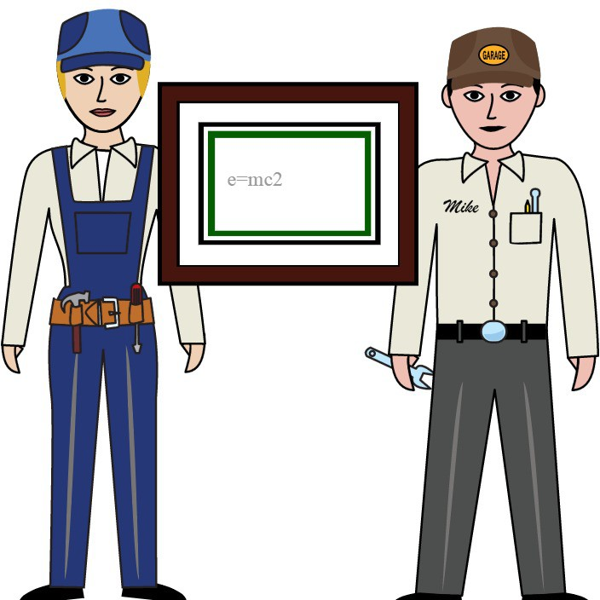MEDIUM CLOSE UP
1.1
1.2
MEDIUM
MEDIUM CLOSE UP

1. Orinda Floccuation Basin
1.3


Intro scene 1 with Maria and Andrew in Control Room
Scene 2 - Andrew enters control room where Maria is
Scene 3 - Andrew and Mara talk about their jobs

MEDIUM MEDIUM
1.4
1.5

Maria Interview - Location TBD
Andrew Interview - Location TBD

