

THE PERFECT STORM

TEACHER’S GUIDE

East Bay Municipal Utility District

2/16/2018

COVER SHEET

The Perfect Storm
Introduction: The following lesson introduces students to linear functions in the context of water pressure vs. water tank’s height.

Materials:

- Projector connected to a computer with internet to play videos for the lesson
- Copies of each of the following:
  - Warm-Up and Exit Ticket
  - The Perfect Storm Worksheet
  - Water Treatment Conversion Sheet Entitled “State of California, Department of Public Health: Drinking Water Operator Certification Program”
  - Student Surveys

Estimated Timeframe:

- 45 minutes to an 1 hour, depending on how you spread and imbed your think time

Prior Knowledge/Skills Needed:

Before this application lesson, students must be able to:

- Find the equation of a line given 2 points
- Find percent of a number

Common Core State Standards:
CCSS.MATH.HS.A-CED.2: Create equations in two or more variables to represent relationships between quantities; graph equations on coordinate axes with labels and scales.
CCSS.MATH.HS.A-REI.3: Solve linear equations and inequalities in one variable, including equations with coefficients represented by letters.
Additional Common Core State Standards:

CCSS.MATH.HS.N-Q.1: Use units as a way to understand problems and to guide the solution of multi-step problems; choose and interpret units consistently in formulas; choose and interpret the scale and the origin in graphs and data displays.
CCSS.MATH.HS.N-Q.2: Define appropriate quantities for the purpose of descriptive modeling. CCSS.MATH.HS.A-SSE.1: Interpret expressions that represent a quantity in terms of its context.
CCSS.MATH.HS.A-CED.3: Represent constraints by equations or inequalities, and by systems of equations and/or inequalities, and interpret solutions as viable or nonviable options in a modeling context.

Implementation Suggestions:

- Ask students to think/write/pair/share often so students can verbalize and communicate their mathematics
- Students should do work on the board in groups or pairs

Accommodations/Modifications:

- For English Language Learners:
  - Be sure to have precise definitions of content vocabulary ready ahead of time.
  - Be sure to include think time when appropriate.
  - Ask students to Think/Write/Pair/Share between for each question
- For SPED/504:
  - Allow students to use a calculator for calculations
  - Focus on having students verbalize the process in their own words
  - While students are finding solutions you may ask students for estimated solutions first, this helps students see if they are headed in the right direction with their answers

Extensions:

- Students can use maximum and minimum values to calculate the lines that represent the upper and lower boundaries of the appropriate
- Students can graph the set of solution values (region between the line representing expected values + 2% and expected values – 2%).

WARM-UP EXERCISE

Warm-Up:
- Find the equation of the line between the points (1.2, −3.5) and (−8.4,7.9).

- You buy a bottle of water that says it should have 16.9 ounces in it, but it actually has 16.5 ounces in it. What is the percent error between those amounts? What does that number mean in this context?

Exit Ticket:
- In your own words, describe what you learned today?

- How difficult did you find this problem?

- What part of the problem was the most difficult for you?

VIDEO

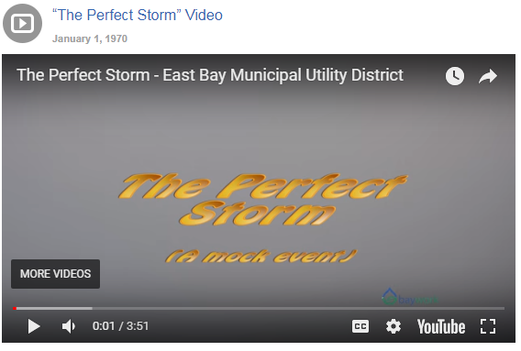

http://baywork.org/resource/the-perfect-storm-video/



http://baywork.org/resource/boris-noss-instrument-technician-east-bay-municipal-utility-district-2/

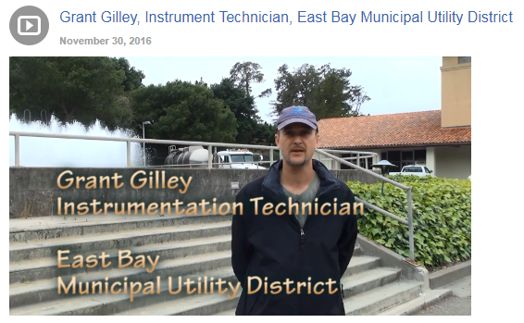

http://baywork.org/resource/grant-gilley-instrument-technician-east-bay-municipal-utility-district/

WORKSHEET

The Perfect Storm Worksheet

The transmitter senses the water pressure (sensor's input), which is determined by the water height in the tank; the transmitter sends a representative signal (transmitter's output) to the plant's control
syst em. The transmitter's LINEAR output signal represents water height in the tank, in such a way that a signal of 4 milliamps represents a water level of 0 feet, and a signal of 20 milliamps represents a level of
  - feet of water. We used this pressure pump to apply a precise pressure to the sensor at 5 points along its "input range" and we wrote down the output signal values for each step. We need to see if the sensor's output is within 2% tolerance, of the original input versus output signal range it was calibrated to represent.
Below are the data we gathered from the transmitter. Is this within tolerance? Use this worksheet to help us solve this problem.

Input (ft) | 0 | 4.9 | 9.8 | 14.7 | 19.6
Actual Output (mA) | 3.96 | 7.76 | 11.52 | 15.52 | 19.4
Expected Output(mA)
Precent Error

The actual output values are the actual values from the tr ans mitt er. We're not sure if they are accurate so we need to find the expected output values from a mathematical model. By comparing the expected and actual output values, we can determine if the transmitter is functioning correctly. To create a math
model we • to know a little about the tank and the tr ansmitt er. The tank can have between Oto 19.6
need
feet of water in it. The transmitter ranges from 4 to 20 mA. Thus if there is 0 feet of water in the tank, the transmitter should read 4mA. If there is 19.6 feet of water in the tank the transmitter should read 20mA . This will take a few ste ps. Are you ready?
Create a linear equation and then fill in the expected output s.

    - Define your variables in a complete sentence and alge braically.

    - Determine the constants of the equation. For linear equations, this is the slope and they­ intercept.

SOLUTION SHEET

The Perfect Storm Worksheet – Answer Sheet

The transmitter senses the water pressure (sensor’s input), which is determined by the water height in the tank; the transmitter sends a representative signal (transmitter’s output) to the plant’s control system. The transmitter’s LINEAR output signal represents water height in the tank, in such a way that a signal of 4 milliamps represents a water level of 0 feet, and a signal of 20 milliamps represents a level of 19.6 feet of water. We used this pressure pump to apply a precise pressure to the sensor at 5 points along its “input range” and we wrote down the output signal values for each step. We need to see if the sensor’s output is within 2% tolerance, of the original input versus output signal range it was calibrated to represent.

Below are the data we gathered from the transmitter. Is this within tolerance? Use this worksheet to help us solve this problem.

Input (ft) | 0 | 4.9 | 9.8 | 14.7 | 19.6
Actual Output (mA) | 3.96 | 7.76 | 11.52 | 15.52 | 19.4
Expected Output(mA) | 4 | 8 | 12 | 16 | 20
Percent Error | -.25% | -1.5% | -3% | -3% | -3.75%

The actual output values are the actual values from the transmitter. We’re not sure if they are accurate so we need to find the expected output values from a mathematical model. By comparing the expected and actual output values, we can determine if the transmitter is functioning correctly. To create a math model we need to know a little about the tank and the transmitter. The tank can have between 0 to 19.6 feet of water in it. The transmitter ranges from 4 to 20 mA. Thus if there is 0 feet of water in the tank, the transmitter should read 4mA. If there is 19.6 feet of water in the tank the transmitter should read 20mA. This will take a few steps. Are you ready?

Create a linear equation and then fill in the expected outputs.

- Define your variables in a complete sentence and algebraically.

Y or Expected Outcome: Milliamps measured by the transmitter when working accurately. The transmitter senses water pressure.

X or Input: Water level in the tank, which is the water height in feet.

- Determine the constants of the equation. For linear equations, this is the slope and the y- intercept.
a: Y-intercept

Y = a + bX; a = Y(When x=0) –bX(x=0); a=Y(When x=0); a = 4 b: the slope
Y = a + bX; Y(when x=19.6) = 4 + b X(X=19.6); 20 = 4 + 19.6b; b = 16/19.6 = .816

- Create the linear equation.

Y = a + bX; Y = 4 + .816X

- Use the input values in the above table and your linear equation to fill in the expected output values in the table. Good job! Compare the actual and expected output values. Are they the same or different? Why?

They are different because the transmitter is not working accurately; it is producing readings that are not free from error.

- A percent is a fraction. To find the Percent Error, divide the difference between the actual and the expected output values by the overall range of the transmitter. Fill in the table.

%𝐸𝑟𝑟𝑜𝑟 = 𝐴𝑐𝑡𝑢𝑎𝑙 − 𝐸𝑥𝑝𝑒𝑐𝑡𝑒𝑑
𝑂𝑣𝑒𝑟𝑎𝑙𝑙 𝑅𝑎𝑛𝑔𝑒

- Are these values positive, negative or both? Why?

They are negative because the transmitter is slightly underestimating the water pressure in the tank. As a result, the transmitter readings obtained represent lower water levels than the actual water levels.

- Are there units for the percent error? Why or why not?

No, percent of error is expressed in percentages, which are "dimensionless" numbers, numbers that have no units attached. In this case, the percent of error is telling us how accurately the transmitter works regardless of the units in which the measurements are expressed.

Great work! Thank you for the careful analysis. Now let’s see if this transmitter is functioning within tolerance. The magic number is 2%. Is the transmitter within 2% tolerance?

No, as the water level in the tank increases the transmitter works less and less precisely. The last three measurements provided by the transmitter have a percent of error higher than 2%.

Essay question

Your boss thanks you for all your hard work and now needs you to write up a report. This report will be read by all new recruits so something like this NEVER HAPPENS AGAIN. Explain in detail exactly what happened:
Paragraph one

- What was the original problem?
- Why did you collect data? Why are you comparing output with the expected value?
Paragraph two

- What did you find? What did the data tell you?
- Was the transmitter functioning within tolerance?
- What do you suggest needs to be done?
The original problem was to determine whether a transmitter used to measure the water pressure in a tank was working accurately enough (i.e., within 2% tolerance – the error in measurement that is acceptable in this case-). I collected data on the actual values provided by the transmitter (i.e., transmitter readings) to compare them with the expected values/readings that a transmitter functioning accurately would have yielded. By doing this, I could compute the percent errors in measurement, and thus determine whether the transmitter was functioning accurately enough (i.e., 2% tolerance). To compute expected values, I created a linear equation. I knew that if there was 0 feet of water in the tank, the transmitter should have read 4mA and that if there was 19.6 feet of water in the tank the transmitter should have read 20mA. I collected both expected and actual values along 5 points in the
“input range”, being the input the water level in the tank.

I found that the transmitter was not functioning within 2% tolerance. Consequently, estimating the water level in the tank could not be done with enough confidence. I suggest having an Instrument Technician calibrate the transmitter in order to obtain accurate transmitter readings so that going forward we can fairly estimate the water level in the tank.

Video 2
Scene 1 - Grant and Boris

- Boris, “Thanks for the help! Did you find that the transmitter was out of tolerance?”
- Grant, “Now we know what to fix. If you’d like more information about the work we do, check out my story on Baywork”
- Weblink appears

EXIT TICKET

Warm-Up:
  - Find the equation of the line between the points (1.2, −3.5) and (−8.4,7.9).

  - You buy a bottle of water that says it should have 16.9 ounces in it, but it actually has 16.5 ounces in it. What is the percent error between those amounts? What does that number mean in this context?

Exit Ticket:
- In your own words, describe what you learned today?

- How difficult did you find this problem?

- What part of the problem was the most difficult for you?

TEACHER’S FEEDBACK FORM

Feedback Form for Teachers (Online)
Online Version of Feedback Form:

https://goo.gl/forms/esHz2B0pokGqqSWP2

Feedback Form for Teachers

  - Information on Teacher and the Module Used Name of Teacher
Date Module was Used

Name of Class in which module was used Number of students in class
Name of school or other organization

Name of the Contextualized Learning Module Used

  - Components of the Contextualized Learning Module Used

Yes No

    - The Problem Illustration Video

    - The Warm-Up Ticket

    - The Cover Sheet

    - The Solution Sheet

    - The Exit Tickets

    - Videos of individual Subject Matter Experts

    - Feedback form for students

  - Feedback on components of the module

The Problem Illustration Video

  - What did you think worked in this component of the module?

  - What did you think didn’t work as well?

  - Do you have any suggestion for how we could make this component of the module more effective in future modules?

  - Not applicable—this component of the module was not used

The Warm-Up Ticket

  - What did you think worked in this component of the module?

  - What did you think didn’t work as well?

  - Do you have any suggestion for how we could make this component of the module more effective in future modules?

  - Not applicable—this component of the module was not used

The Cover Sheet

  - What did you think worked in this component of the module?

  - What did you think didn’t work as well?

  - Do you have any suggestion for how we could make this component of the module more effective in future modules?

  - Not applicable—this component of the module was not used

The Solution Sheet

  - What did you think worked in this component of the module?

  - What did you think didn’t work as well?

  - Do you have any suggestion for how we could make this component of the module more effective in future modules?

  - Not applicable—this component of the module was not used

The Exit Tickets

  - What did you think worked in this component of the module?

  - What did you think didn’t work as well?

  - Do you have any suggestion for how we could make this component of the module more effective in future modules?

  - Not applicable—this component of the module was not used

Videos of individual Subject Matter Experts

  - What did you think worked in this component of the module?

  - What did you think didn’t work as well?

  - Do you have any suggestion for how we could make this component of the module more effective in future modules?

  - Not applicable—this component of the module was not used

- Feedback form for students

  - What did you think worked in this component of the module?

  - What did you think didn’t work as well?

  - Do you have any suggestion for how we could make this component of the module more effective in future modules?

  - Not applicable—this component of the module was not used

y

STUDENTS FEEDBACK FORM

Feedback Form for Students (Online)

Go here for the Online Version of Feedback Form: https://goo.gl/forms/3vSjzMuzFDuxY1y73

Feedback Form for Students
Please rate each of the following aspects of this lesson:

 | Excellent | Very  Good | Good | Fair | Poor | Very  Poor
1. Video
2. Lesson Presentation
3. Worksheet
4. Time Allotted

  - What aspect or part of this lesson do you believe was the most effective at helping you reach the learning goal?

  - Where would you have wanted more training or help on this?

  - Did this curriculum increase your awareness of the water/wastewater industry?

  - Additional Comments/Suggestions:

SCRIPT

The Perfect Storm By
East Bay Municipal Utility District

www.baywork.org

INTRODUCTION

GRANT GILLEY BORIS NOSS

Grant and Boris standing outside EBMUD plant
GRANT GILLEY
Hi. My name is Grant Gilley.
BORIS NOSS
And my name is Boris Noss. We are instrument technicians at East Bay Municipal Utility District.
GRANT GILLEY
Our math skills are necessary in order for our agency to provide reliable water and wastewater service to over a million people in Northern California.
BORIS NOSS
We know that students sometimes wonder where they will need to use math skills - we know we did when we were in school. We thought it might interest you to see an example of why math matters. The following is a mock event.
SCENE 1 - CONTROL ROOM
Boris is sitting at a chair with his coffee, looking at the monitors.

GRANT GILLEY
"Boris, There’s a problem! The water tank is overflowing!!"
BORIS NOSS
"What? The water levels are fine"
cut to computer screen showing all is fine
GRANT GILLEY
"Dude, get out of that chair and look outside!" cut to overflowing tank and thunderstorm

(CONTINUED)

CONTINUED: 2.

BORIS NOSS
"Oh man why didn’t you tell me sooner?" Grant shakes his head
BORIS NOSS
(On the phone) "Turn the pumps off now!"
Cut to sign saying "Later..." SCENE 2 - CONTROL ROOM
GRANT GILLEY

"So what happened?"
BORIS NOSS

"We don’t know. It could be due to calibration error in the transmitter. Let’s take a look."
SCENE 3 - TRANSMITTER SET-UP IN SHOP
BORIS NOSS
The transmitter senses the water pressure, which is determined by how much water is in the tank; the more water is in the tank, the higher the water pressure will be. The transmitter sends this information to the plant’s control system.

GRANT GILLEY
The transmitter’s LINEAR output signal represents water height in the tank. In this case, a signal of 4 milliamps represents a water level of 0 feet, and a signal of 20 milliamps represents a level of 19.8 feet of water. . .
Let’s use this pressure pump (hold up instrument to camera) to test whether the transmitter is working correctly. We will apply pressure to the sensor at 5 points along its input range and write down the output signal values for each step.

BORIS NOSS
(Looking at camera and speaking to the audience.)

We need to see if the numbers recorded by the transmitter are within 2% of the actual pressure being applied by the pressure pumps. Can you help us out?"

3.

ENDING
BORIS NOSS

Being an instrument technician in the water industry is a great job.

GRANT GILLEY
If you’d like to hear more about how Boris and I got our jobs and how you could prepare yourself for a career in the Water or Wastewater industry, please visit the BAYWORK website to hear our personal stories. The career section of the website is full of information about great water industry jobs.

STORYBOARD

WIDE
1.1
MEDIUM
MEDIUM

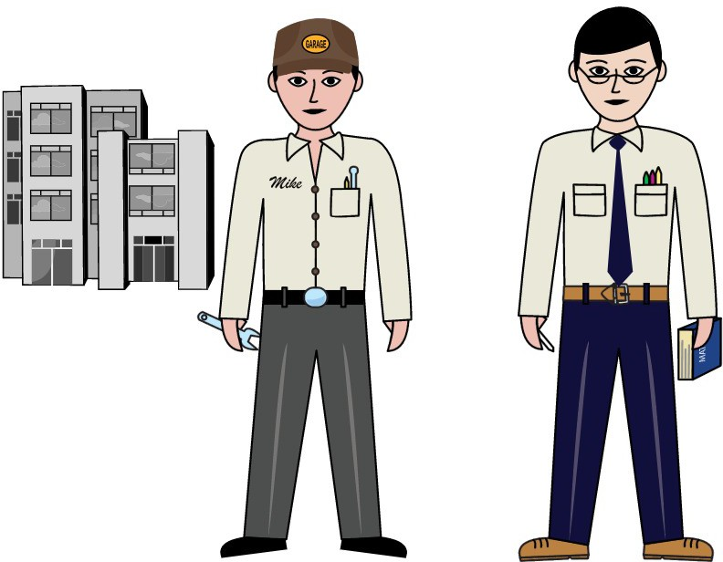
EBMUD shot of entrance
Grant and Boris Intro
Boris at computer looking at screen

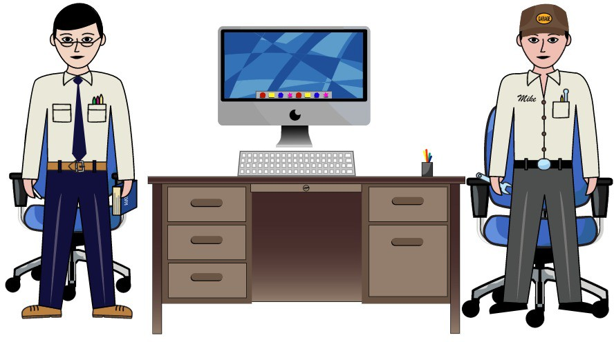MEDIUM
1.4
WIDE
MEDIUM

1. The Perfect Storm
1.2
1.3
1.5
1.6

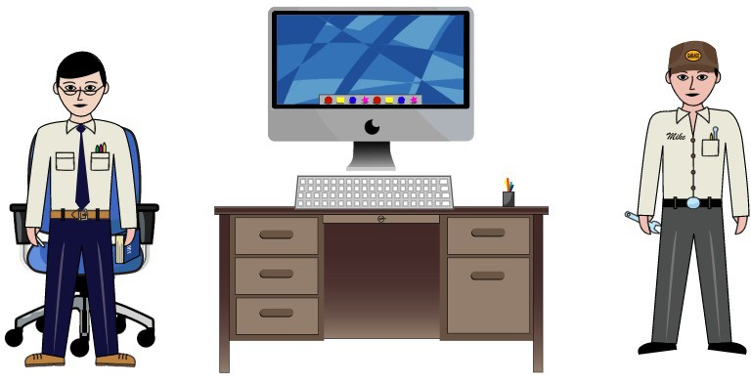
Grant rushes in out of breath.
overflowing tank and thunderstorm, rain sounds
Control room Grant - What happened? Boris
- Let's take a look.

MEDIUM MEDIUM
1.7
1.8
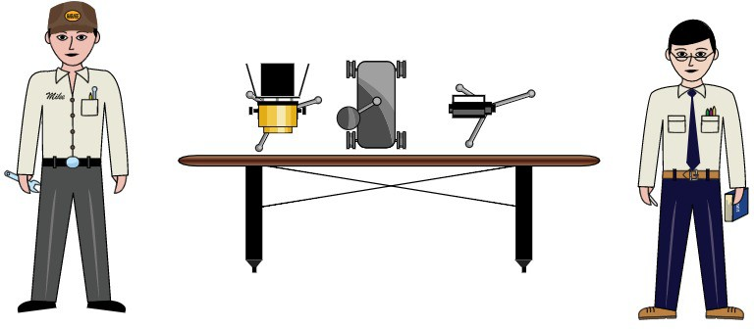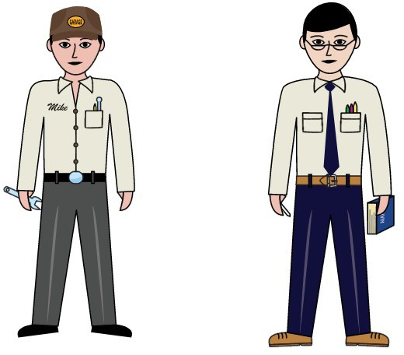
room with transmitter
grant and boris talk about candidate development vids

